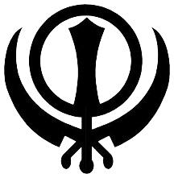
Quiz On Punjab
- What is the meaning of word ‘Sikh’?
- What is the meaning of Punjab?
- What does 5 Ks stands for in Sikhism
- What does Gurudwara mean?
- Punjabi men wearing full turban are called what?
- What is Sikh holy book called?
- What is the ceremonial dagger carried by khalsa Sikhs?
- How many Sikh gurus were there?
- What is Sikh flag called?
- Who was the first Guru?
- What is the meaning of ‘Kaur’ female middle name in Sikhs?
- What does word ‘Singh’ means?
- Who was the youngest Guru to die?
- What is Guru Nanak’s Jayanti called?
- What is folk dance of Malwa region of Punjab?
- What is popular dish of Punjab?
- Popular dance form of Punjab?
- What does ‘Laung’ means?
- World famous wrestler from Punjab?
- Cricketer from Punjab?

www.kittygroups.com

