Ek Villain: Guess the Bollywood Villains

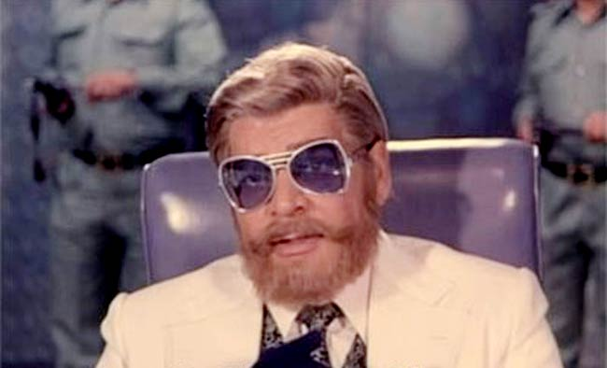 Ajeet – Lion—KaaliCharan
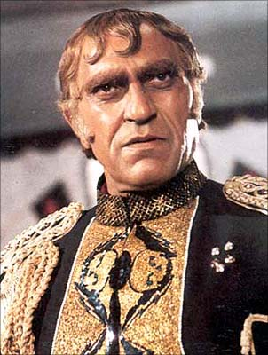
Amrish Puri—Mogambo—Mr. India
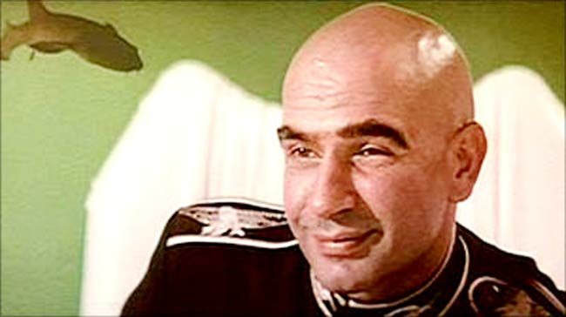 Kulbhushan —Shaakaal-- Shaan
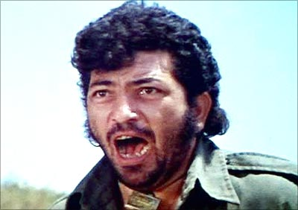 Amjad Khan—Gabbar--Sholey
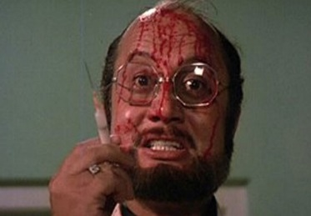Anupam Kher—Dr. Dang--Karma
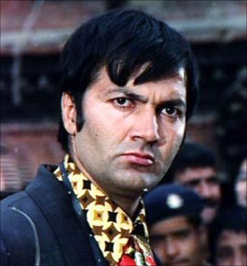Prem Chopra—Prem--Bobby

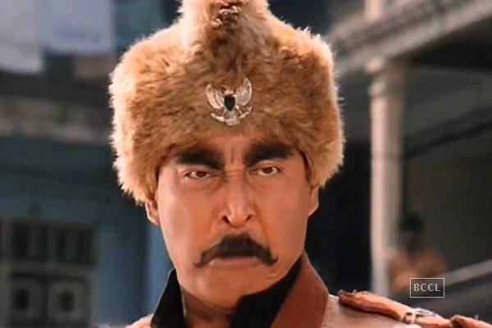Danny-Katya--Ghatak

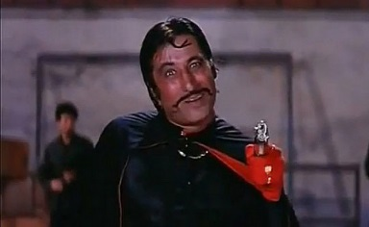Shakti Kapoor-Gogo-Andaz Apna Apna
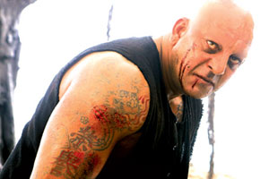 Sanjay Dutt—Kancha Cheena--Agneepath
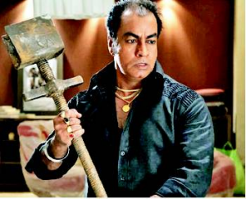Pradeep Rawat—Gajini--Gajini
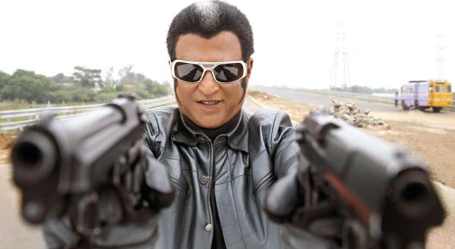Rajnikanth—Chitti—Robot
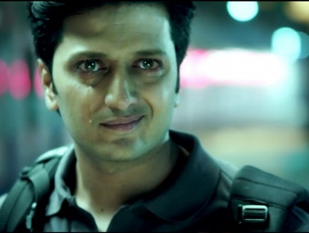 Ritesh Deshmukh—Rakesh—Ek Villain

